Create a list on a classic SharePoint or a SharePoint Server 2019 site

1. Select **Settings** Settings icon, and then select **Site contents**.
2. Select **+ New**, and then select **List**.
3. Enter a **Name** for the list, and optionally, a **Description**.

The name appears at the top of the list and can appear in site navigation to help others find it.

1. Select **Create**.
2. When your list opens, to add room for more types of information to the list, select **+** or **+ Add column**.

Add a column to a list or library

You can add most types of columns without leaving your list or library.

1. Navigate to the list or library you want to create a column in.
2. To the right of the last column name at the top of the list or library, select **+ Add column** or **+**.

**Note:**Does your SharePoint screen look different than the examples here? If so, select the **Classic** tab earlier in this article. You'll find alternate instructions there that'll match your experience better if your administrator set the classic experience on the list or document library, or if you're using an earlier version of SharePoint Server. See [Which version of SharePoint am I using?](https://support.microsoft.com/en-us/office/which-version-of-sharepoint-am-i-using-3575ff57-037f-48cf-9398-99080c34b25f)

1. In the dropdown, select the type of column you want.
2. In the **Create a column** panel, in the **Name** field, enter a title or column heading.

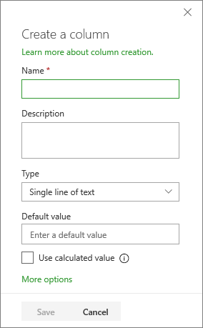

1. Enter any other required information. The number of fields will vary with column type you choose. The above example is for a 'number' field.
2. Select **Save**.

Add more columns types to a list or library

1. Navigate to the list or library where you want to create a column.
2. In the **All items** or **All documents** view of the list or library you want to add a column, select **Add column**   Add column icon at the end of the heading row, and then select **See all column types**. Select **Next**.
3. In the **Name and Type** section, enter the name that you want for the column in the **Column name** field.
4. Under **The type of information in this column is**, select the type of information that you want to appear in the column. For more info about column types, see [Site column types and options](https://support.microsoft.com/en-us/office/list-and-library-column-types-and-options-0d8ddb7b-7dc7-414d-a283-ee9dca891df7).
5. In the **Additional Column Settings** section, enter a description in the **Description** field to help people understand the purpose of the column and what data it should contain. This description is optional.

Depending on the type of column that you selected, more options may appear in the **Additional Column Settings** section. Select the additional settings that you want. For more info about column settings, see [Site column types and options](https://support.microsoft.com/en-us/office/list-and-library-column-types-and-options-0d8ddb7b-7dc7-414d-a283-ee9dca891df7).

1. You can add validation to make sure the column entry matches what's expected. To expand the section, select **Column Validation**, and enter the **Formula** that you want to use to validate the data. Add a **User message** that describes what valid data should look like to help users enter valid data. For info about validation and formula syntax, see [Examples of common formulas in lists](https://support.microsoft.com/en-us/office/examples-of-common-formulas-in-lists-d81f5f21-2b4e-45ce-b170-bf7ebf6988b3).

The **Column Validation** section is not available for all types of columns.

1. To save, select **OK**.